C:\Users\User\Pictures\2023-09-28\004.tif

C:\Users\User\Pictures\2023-09-28\005.tif

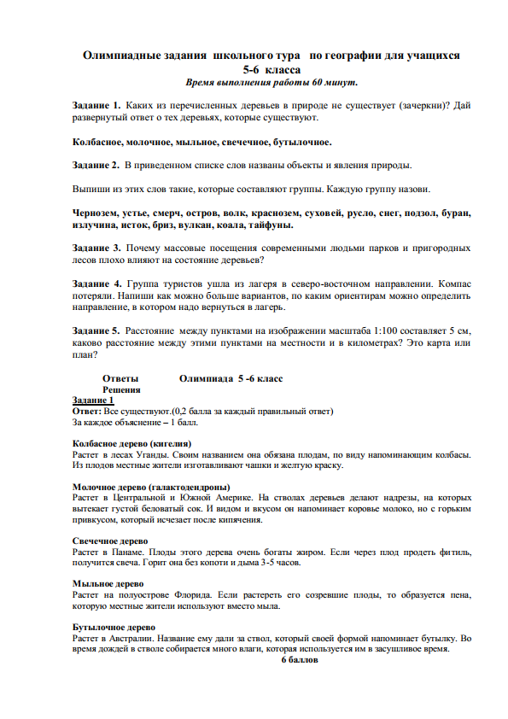

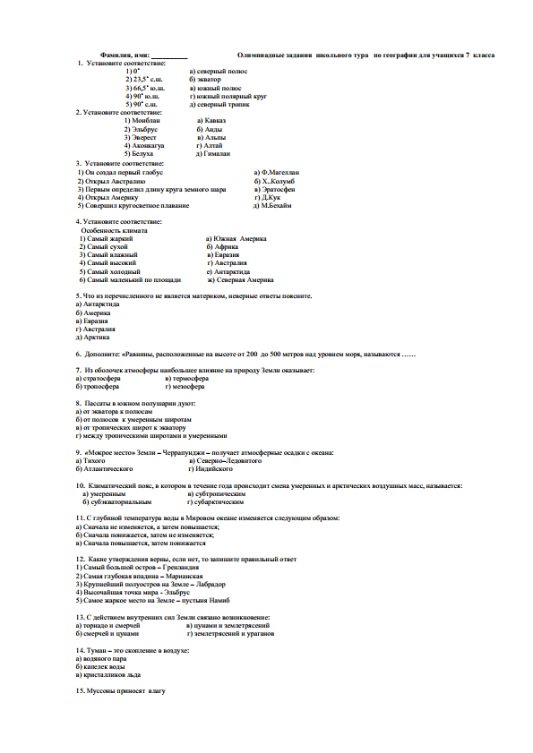

C:\Users\User\Pictures\2023-09-28\010.tif

C:\Users\User\Pictures\2023-09-28\011.tif